## Your Workspace

### For the purpose of this explanation we will be using the **New Default Plan** in the following section.

Before you get started with RapidPlan, you should probably get to know your way around the main screen. It has been designed to be intuitive, easy to follow and to allow you the maximum available working space to create your traffic plan.

There are three main components of the RapidPlan workspace:

* The Toolbar
* The Palettes
* The Canvas

Organizing your workspace is simple as each of the items that sit on the canvas can be moved around. Generally, your screen will be laid out similar to as is shown below.

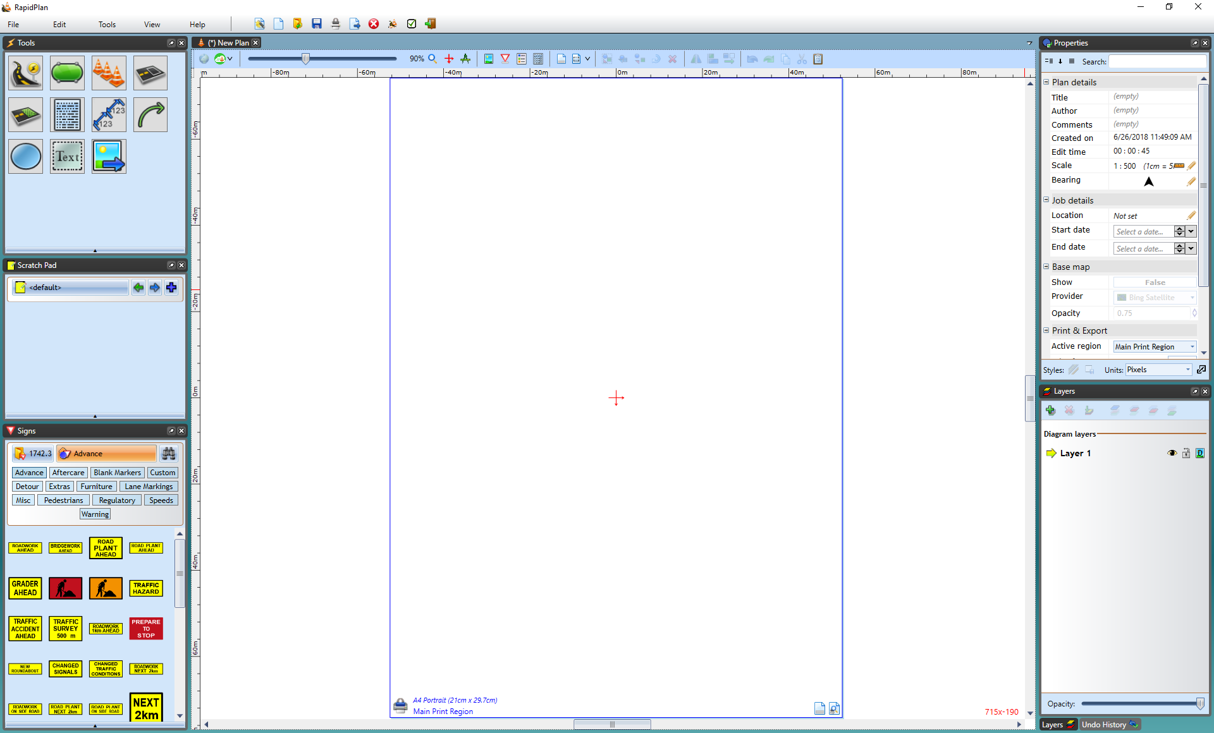

workspace